**NAAN MUDHALVAN**

SALESFORCE PROJECT REPORT

**COLLEGE : SCAD COLLEGE OF ENGINEERING AND TECHNOLOGY**

**PROJECT TITLE : APPLICATION TO MAKE THE GAS FILLING STATION USING CRM**

**BATCH : 20**

|  |  |  |
| --- | --- | --- |
| **NAME** | **NM ID** | **REG. NO** |
| **MUTHU KRISHNAN G** | **82EDAFD5C1F1F228E7C40ECAEDC3E33D** | **952820124542** |
| **PERIYASAMI M** | **B069150633CE73C88624BDC7766452E0** | **952820124861** |
| **PERUMAL RAJA N** | **1241EEBCAE94785BDA54D7DB4A5202D2** | **952820125150** |
| **POORANASELVAM S** | **91ED745D4A263B29E624DE1141598994** | **952820124223** |

**MILESTONE 1 : CREATION OF DEVELOPER ACCOUNT**

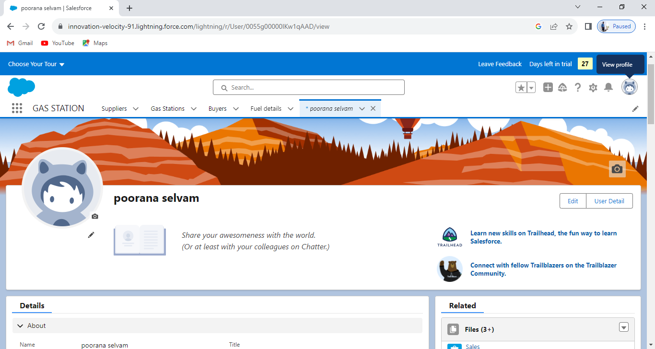

**MILESTONE 2 : OBJECT CREATION**

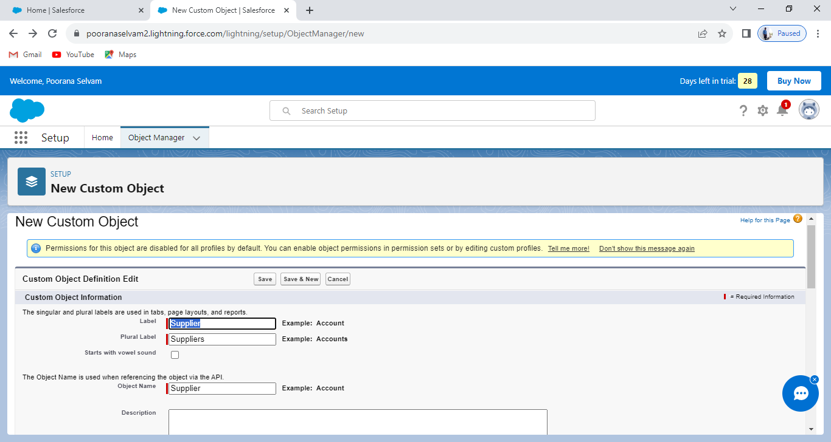

**MILESTONE 3 : TABS CREATION**

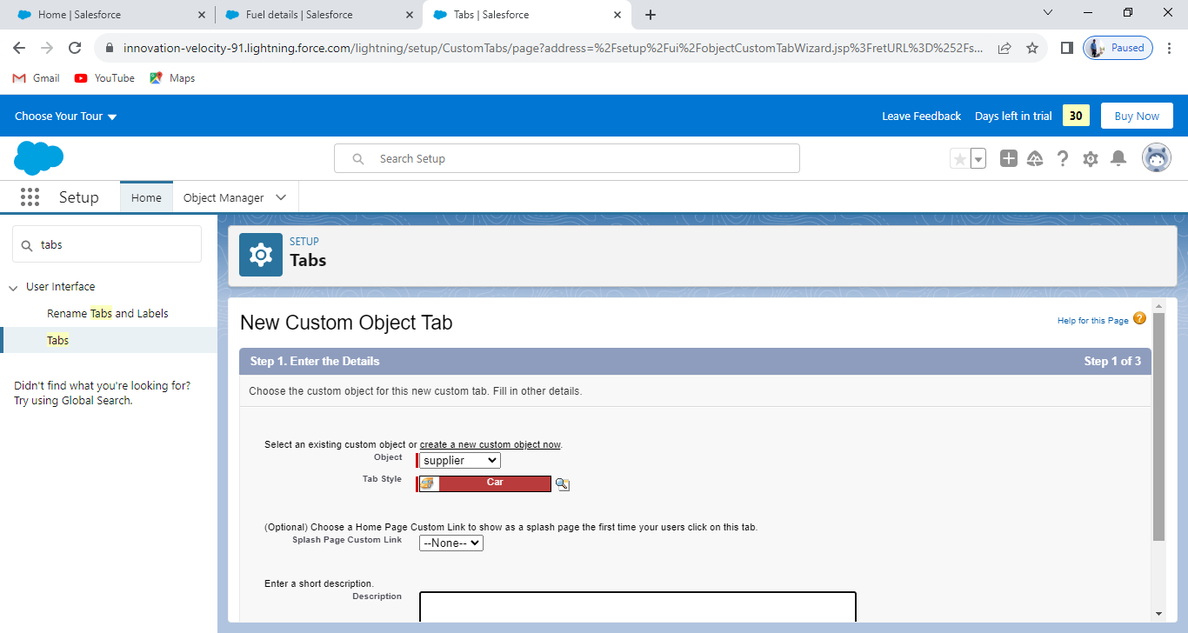

**MILESTONE 4 : CREATE APP**

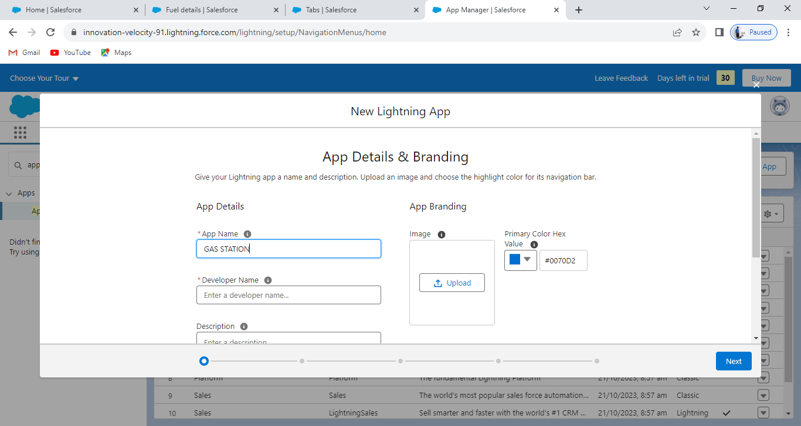

**MILESTONE 5 : FIELDS & RELATIONSHIPS**

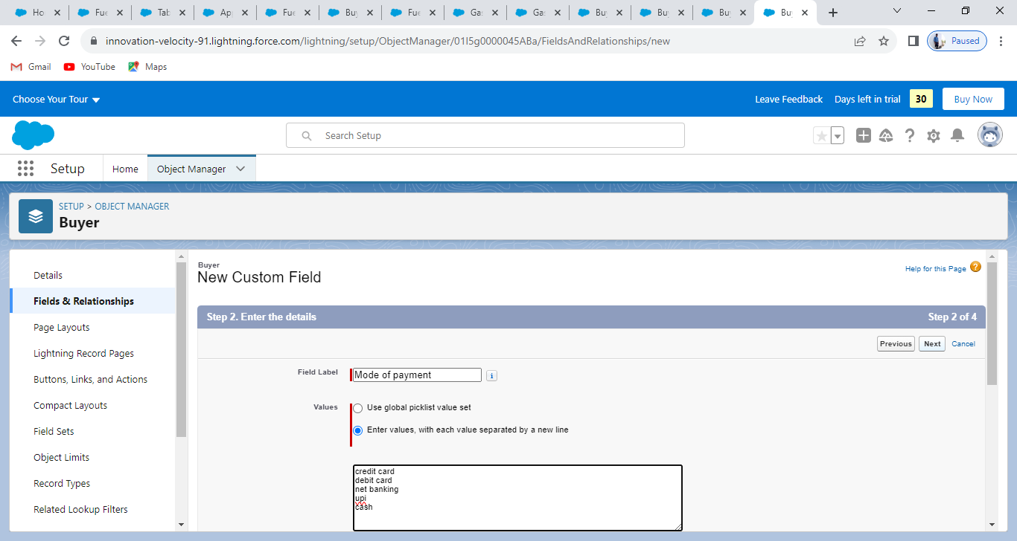

**MILESTONE 6 : PAGE LAYOUT**

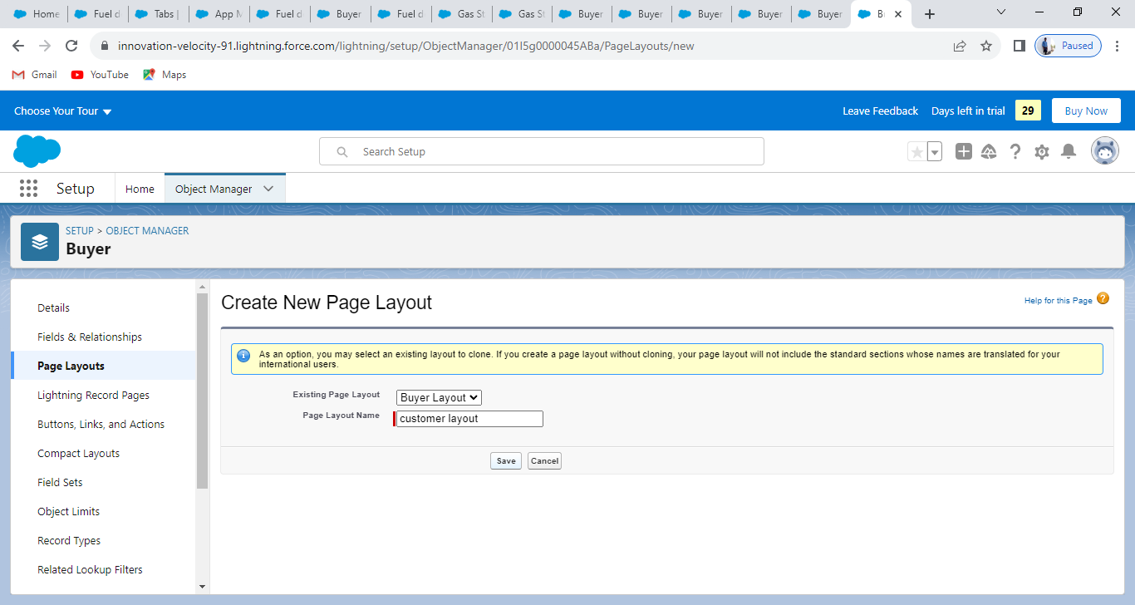

**MILESTONE 7 : PROFILE**

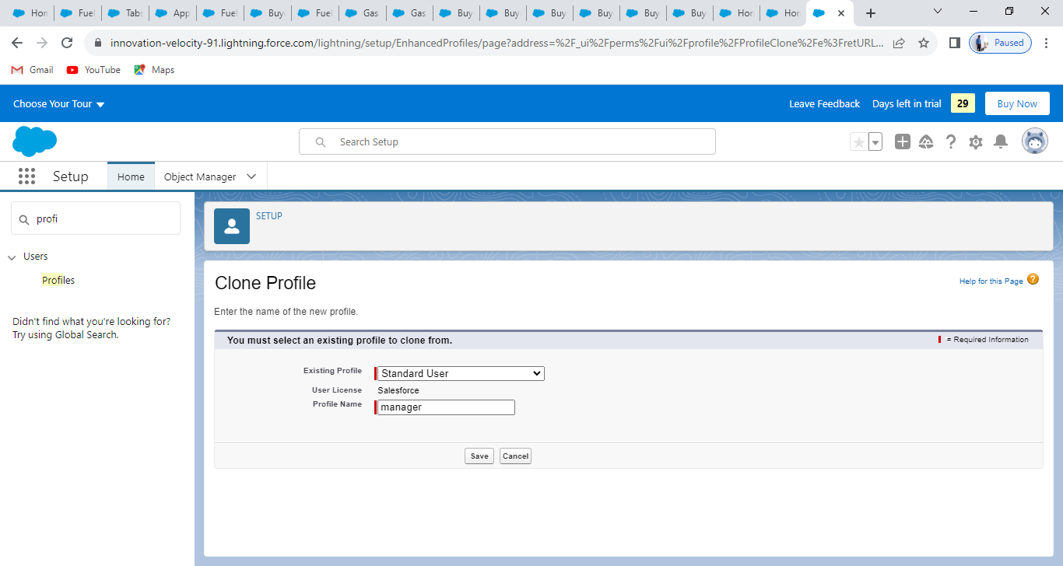

**MILESTONE 8 : ROLE AND ROLE HIRERARCHY**

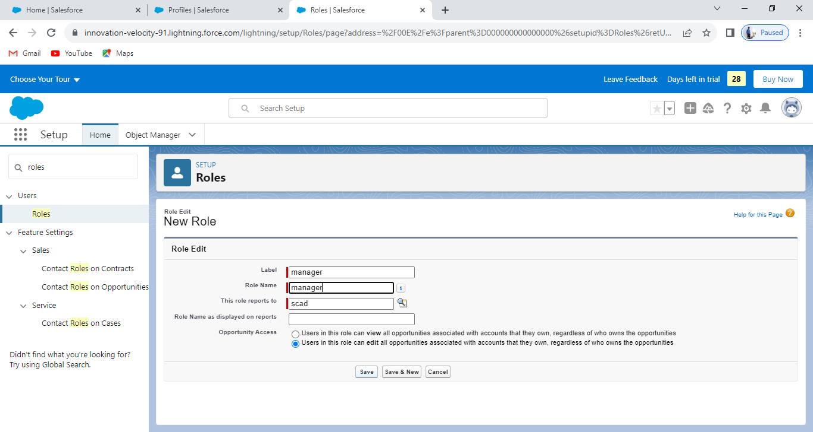

**MILESTONE 9 : USERS**

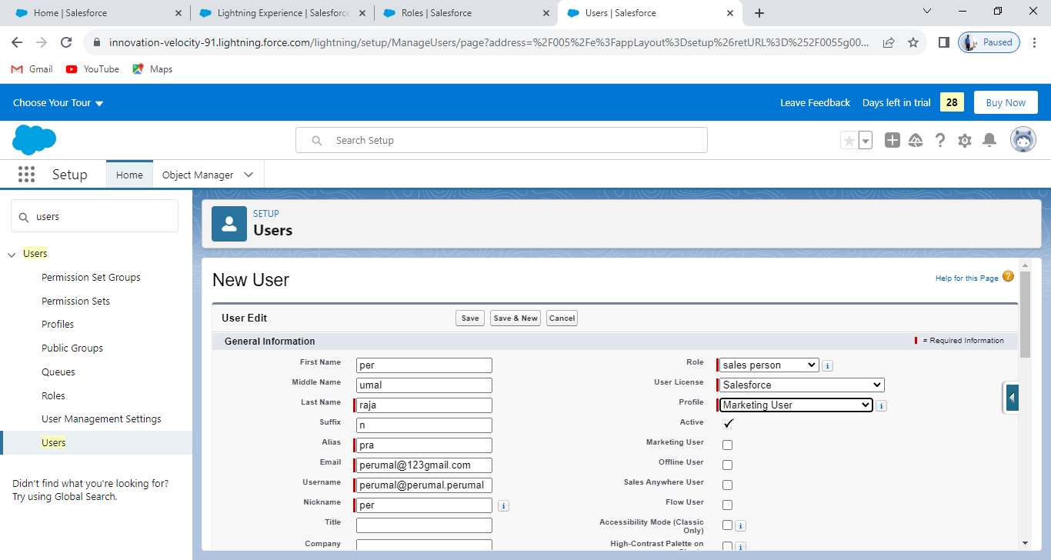

**MILESTONE 10 : PERMISSION SETS**

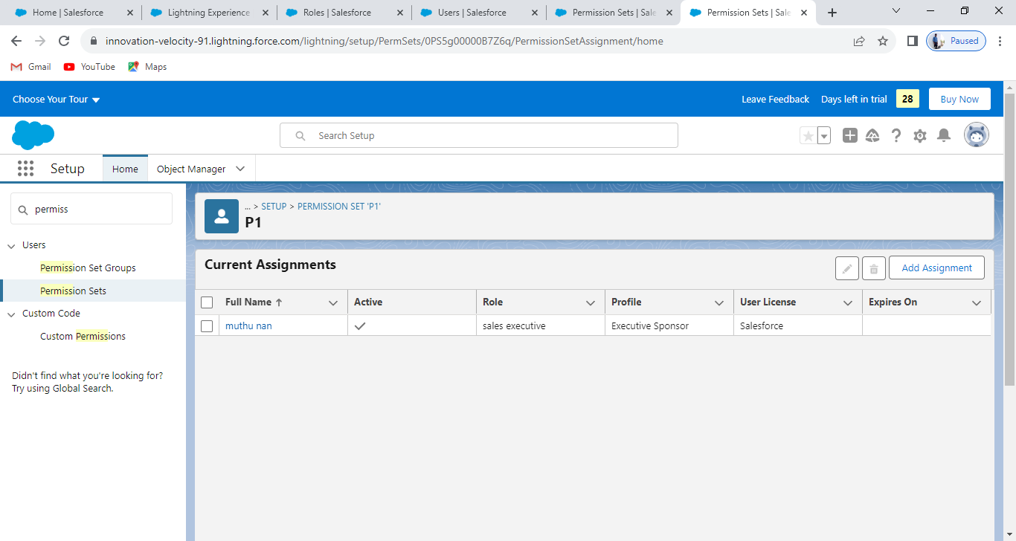

**MILESTONE 11 : USER ADOPTION**

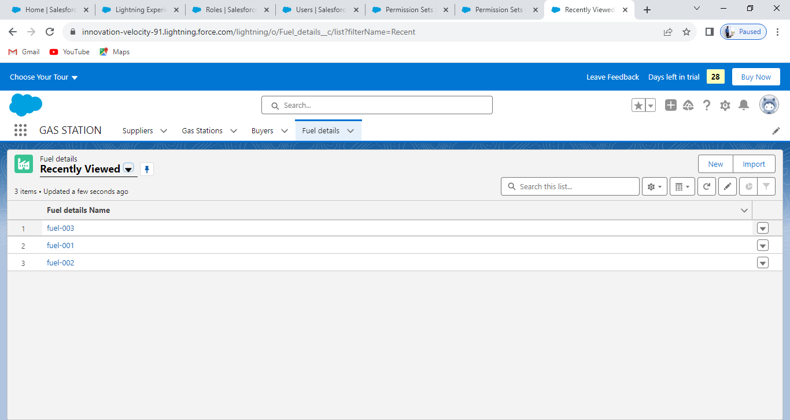

**MILESTONE 12 : REPORTS**

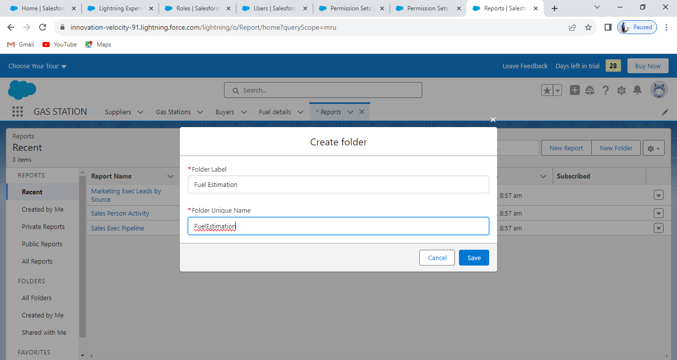

**MILESTONE 13 : DASHBOARDS**

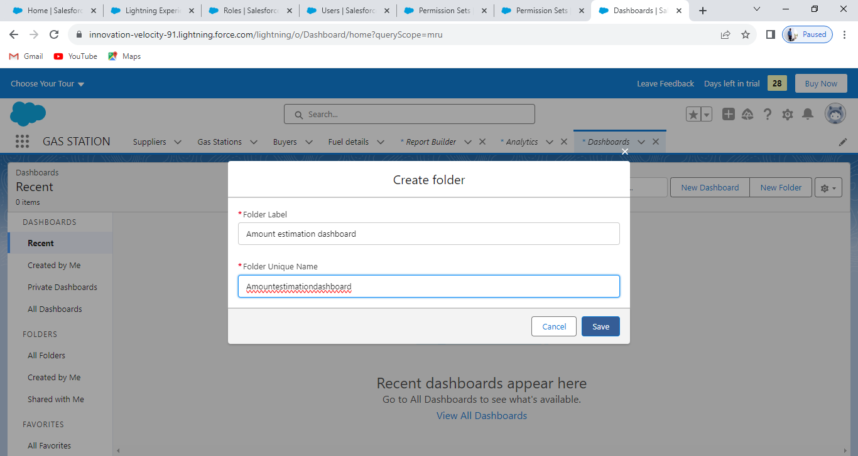

**MILESTONE 14 : FLOWS**

